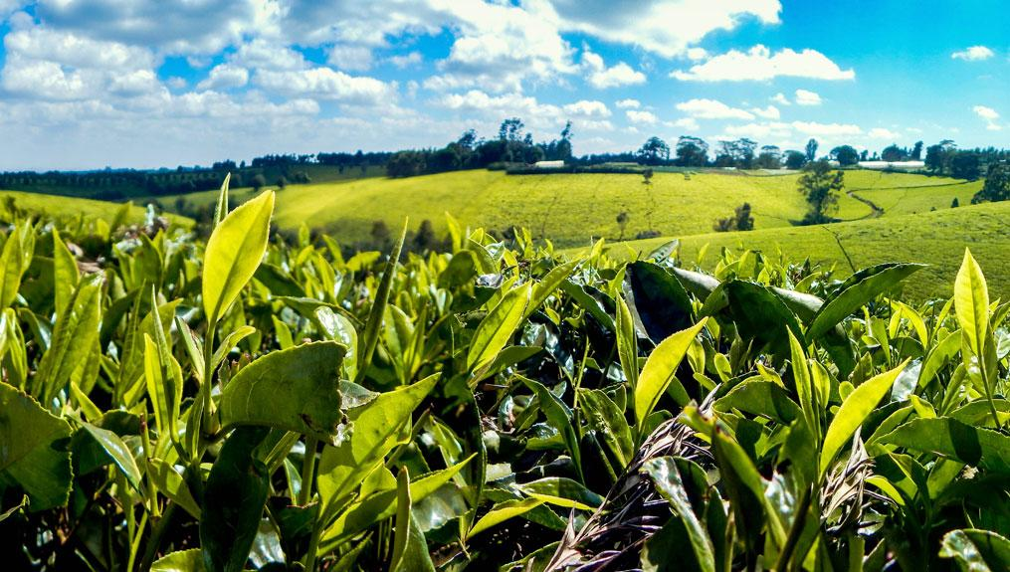
THE VALUABLE OF KENYA TEA
Tea is an evergreen shrubs or small trees that are cultivated and processed to make dried leaves for drinking and also used in some cases for herbal purposes.
According to legend in china they state that tea was used as early as 2700BCE as a herbal medicine but later in around 3rd century it become a dairy for drinking where processing and cultivation began.
In 350BC the first record of planting, processing and drinking was recoded. Tea growing processing and drinking continued to spreed all over the world and around late 19th-early 20th century it arrived in kenya .
Where researchers Joizy Pius Engunjobi and Stephen Asatsa in a research stated that 95.3% of kenya use tea dairy and about 76.4% use 2-3 cups a day.
According to Kenya tea industry performance report 2024 they stated that kenya produced an approximate of 585,533 metric tones of processed tea which made Kenya the third highest producer of tea below China and India. Kenya produce tea in two main blocks as stated by tea board of Kenya. The east of rift block and the west of rift block, the east block including Mt Kenya(Kiambu, Muranga, Nyeri, Kirinyaga, Meru and Tharaka Nithi.) Nyambeni Hills and the Aberdares ranges producing 32%. While 68% coming from the west of rift block including Nandi, Trans Nzoia, E.Markwet, Kakamega, Vihiga, Kericho, Bomet, Kisii,Nyamira and Nakuru.
Tea as indicated in those counties does not grow everywhere it has favourable climate to grow it according to Tea board of kenya that they should be planted in high potential kenya highlands which is 1500-2700m above sea level with an annual rainfall of 1200-1500mm.
In kenya the most common form of plantation is through nurseries which stays for 9-12months before transplanting and after transplanting it takes at least two years to where picking can be done. After that the tea(Camellia sinensis) can lust for a period of 50-80years.
The tea leave undergo processing by first weathering where the leafs are spread to reduce moisture, then they are oxidised before dried.
Then tea is graded in two category, primary and secondary where primary are broken pekoe1 big particles, pekoe farnning1, pekoe dust and dust 1,while the secondary grade are fanning1 and broken mixed fanning.
The government of kenya also involves it in tea sector by financing,regulating and reinforcing tea sector.
But this tea which is one of wealthy of kenya might be affected or end up less productive if there are no regulation and masseuse taken when it comes to climate change as stated by eco-business they said “study has predicted that optimal conditions for growing tea in Kenya will be reduced by a quarter (26.2 per cent) by 2050.
Kenya’s most optimal tea-growing areas such as Mt Elgon and Mbeere are totally absent from the climate projections for 2050, according to the study. It also predicts that tea production in Kenya’s average tea-growing areas will fall by 39 per cent by 2050.Kenya’s temperature will rise by 2.5 degrees Celsius between 2000 and 2050, according to the report. The country will be extreme rainfall events. The Rift Valley region will especially be affected.(by Eco-business)”
This is a big threat to kenyan tea and climate change should be a factor to consider not only in tea sector but even in other farming activities.
Nickson Ngigi
Student,Editor, Journalist.

